**ME 409 Term Project**

1. Tank T1 in Figure initially contains 200 gal of water in which 160 lb of salt are dissolved. Tank T2 initially contains 100 gal of pure water. Liquid is pumped through the system as indicated, and the mixtures are kept uniform by stirring. Find the amounts of salt y1(t) and y2(t) in tank 1 and tank 2, respectively.

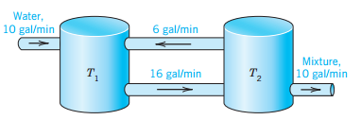

1. Repeat the same problem for which T1 contains: 50, 100, 150, 200, 250 gal of water and T2 contains 10, 20, 50, 200, 500 gal of water. (25 combinations)
2. Repeat the same problem if the flow from tank T1 to T2 changes from 1,2,5,10,20 gal/min and T2 to T1 1,2,5,10,100 gal/min (25 combinations)

Make sure Parts 2 and 3 are done in a programming language like MATLAB

1. Write a report with the results you have obtained.

**Bonus points for using programming language and a functioning program and for using LATEX instead of Microsoft Word.**